Wiltshire Accommodations…
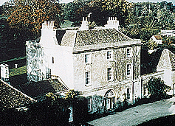
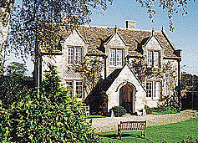
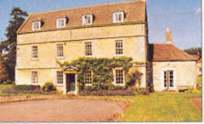
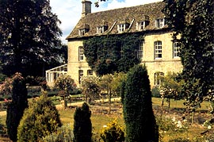

CHURCH HOUSE OLD RECTORY PICKWICK LODGE FARM OLD RECTORY
GRITTLETON LUCKINGTON CORSHAM CRUDWELL

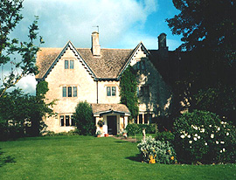
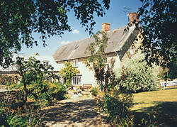
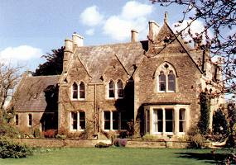
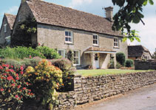

OLD RECTORY WINKWORTH FARM MANOR FARM MANOR FARM
LACOCK LEA CRUDWELL ALDERTON

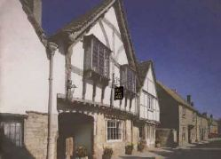
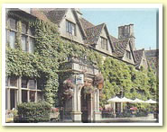
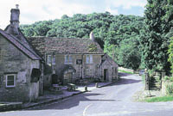
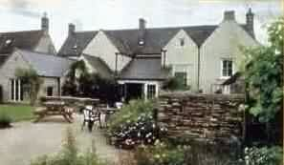

WHITE HART SIGN OF THE ANGEL THE OLD BELL THE KINGS ARMS
FORD LACOCK MALMESBURY DIDMARTON

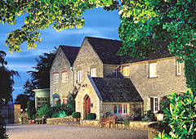
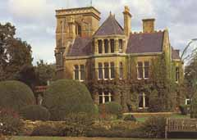
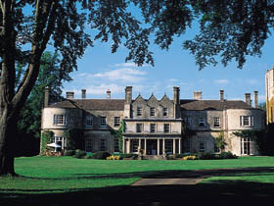
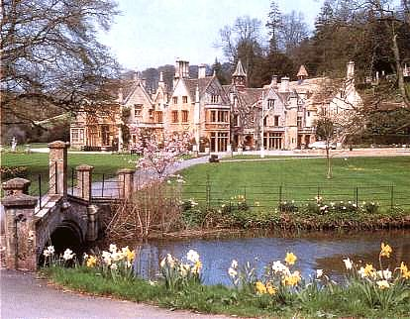

CALCOT MANOR RUDLOE HALL THE MANOR HOUSE LUCKNAM PARK

TETBURY CORSHAM CASTLE COMBE COLERNE

CHURCH HOUSE, GRITTLETON – 18th Century Georgian Rectory. Wonderful house, but fairly basic bedrooms.
4 rooms. Bed and Breakfast from £ 35 per person. Restricted smoking. No credit cards.
Tel: +44 1249 782562, Fax; +44 1249 782546, e-mail: moore@flydoc.fsbusiness.co.uk
Further info: www.karenbrown.com/england/churchhouse.html

THE OLD RECTORY, LUCKINGTON – 14TH century Rectory on upper reach of River Avon.
2 rooms. Bed and Breakfast from £ 35 per person. No smoking. No credit cards.
Tel: +44 1666 840556, Fax: +44 1666 840989, e-mail: b&b@the-eldreds.co.uk
Further info: www.karenbrown.com/england/oldrectoryluckington.html

PICKWICK LODGE FARM, CORSHAM – Grade II Listed 17th Century farmhouse on working farm.
3 rooms. Bed and Breakfast from £ 24 per person. No smoking. No credit cards.
Tel: +44 1249 712207, Fax: +44 1249 701904, e-mail: B&B@PickwickFarm.freeserve.co.uk
Further info: www.information-britain.co.uk/showPlace.cfm?Place_ID=1130

THE OLD RECTORY, CRUDWELL – Saxon Rectory in 3 acres of landscaped Victorian Gardens.
12 rooms. Bed and breakfast from £ 49 per person. No smoking rooms. All major credit cards accepted.
Tel: +44 1666 577194, no Fax, e-mail: office@oldrectorycrudwell.co.uk
Further info: www.oldrectorycrudwell.activehotels.com/MIL

THE OLD RECTORY, LACOCK – Superb example of Grade II listed Victorian Gothic house.
6 rooms. Bed and breakfast from £ 22.50 per person. No smoking rooms available. No credit cards.
Tel: +44 1249 730335, Fax: +44 1249 730166, e-mail: sexton@oldrectorylacock.co.uk
Further info: www.oldrectorylacock.co.uk

WINKWORTH FARM, LEA – Splendidly isolated and delightful 18th Century farmhouse with an enchanting walled garden.
3 rooms. Bed and breakfast from £ 25 per person. No smoking. No credit cards.
Tel: +44 1666 823667, no fax, e-mail: doinewman@winkworth89.freeserve.co.uk
Further info: www.sawdays.co.uk

MANOR FARMHOUSE, CRUDWELL – 18th Century honey-coloured farmhouse, with Cotswold stone roof covered with moss and lichen.
2 rooms. Bed and breakfast from £ 30 per person. No smoking. No credit cards.
Tel: +44 1666 577375, no fax, no e-mail
Further info: www.sawdays.co.uk or www.stayinstyle.com/bbprofile.cfm?currentrow=19&section=Wiltshire&search=location

THE MANOR FARMHOUSE, ALDERTON – 17th Century farmhouse in an unspoilt village with duck pond.
3 rooms. Bed and breakfast from £ 30 per person. No smoking facilities. No credit cards.
Tel: +44 1666 840271, Fax: Same, e-mail: bookings@themanorfarm.co.uk
Further info: www.historic-uk.com/StayUK/South/BandB/manorfarm.htm

THE WHITE HART INN, FORD - Stunning 15th century pub with wonderful food.
11 rooms. Bed and breakfast from £ 29.50 per person. No smoking facilities. All major credit cards accepted.
Tel: +44 1249 782213, Fax: +44 1249 783075, e-mail: whitehart.ford@eldridge-pope.co.uk
Further info: Website coming soon.

THE SIGN OF THE ANGEL, LACOCK - Venerable 15th Century small hotel in a stunning village location.
10 Rooms. Bed and breakfast from £ 50 per person. No smoking facilities. All major credit cards accepted.
Tel: +44 1249 730230, Fax: +44 1249 730527, e-mail: Angel@lacock.co.uk Further info: www.lacock.co.uk

THE OLD BELL, MALMESBURY – Dating from the 12th Century, this is reputedly England’s oldest hotel.
31 rooms. Bed and breakfast from £ 57.50 per person. No smoking facilities. All major credit cards accepted.
Tel: +44 1666 822344, Fax: +44 1666 825145, e-mail: info@oldbellhotel.com
Further info: www.oldbellhotel.com

THE KINGS ARMS, DIDMARTON – A lovingly restored 17th Century Coaching Inn with outstanding food, set in a very attractive village
4 rooms. Bed and breakfast from £ 35 per person. Restricted smoking facilities. Most major credit cards accepted.
Tel: +44 1454 238245, Fax: +44 1454 238249, e-mail: info@kadidmarton.com
Further info: www.kadidmarton.com

CALCOT MANOR, TETBURY – Romantic former farmhouse built in the 14th Century by monks.
28 rooms. Bed and breakfast from £ 72.50 per person. Restricted smoking facilities. All major credit cards accepted.
Tel: +44 1666 890391, Fax: +44 1666 890394, e-mail: reception@calcotmanor.co.uk
Further info: www.calcotmanor.co.uk

RUDLOE HALL, CORSHAM – Gothic Victorian country house hotel set in antique gardens and woodland.
11 rooms. Bed and breakfast from £ 59.50per person. Restricted smoking facilities. All major credit cards accepted.
Tel: +44 1225 810555, Fax: +44 1225 811412, e-mail: mail@rudloehall.co.uk
Further info: www.rudloehall.co.uk

THE MANOR HOUSE, CASTLE COMBE – 14th Century manor house nestled in 365 acres of woodland.
47 rooms. Bed and breakfast from £ 145 per person. No smoking facilities. All major credit cards accepted.
Tel: +44 1249 782206, fax: +44 1249 782159, e-mail: enquiries@manorhousecc.co.uk
Further info: www.exclusivehotels.co.uk/webenglish/manorhouse/home.html

LUCKNAM PARK, COLERNE – Stunning 17th century Palladian Manor house set in glorious parkland.
41 rooms. Room only from £ 102.50 per person. No smoking facilities. All major credit cards accepted.
Tel: +44 1225 742777, Fax: +44 1225 743536, e-mail: reservations@lucknampark.co.uk
Further info: www.lucknampark.co.uk

