Warwickshire…
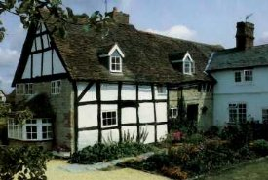
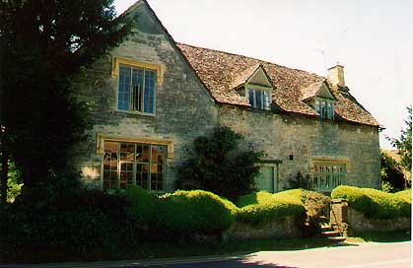
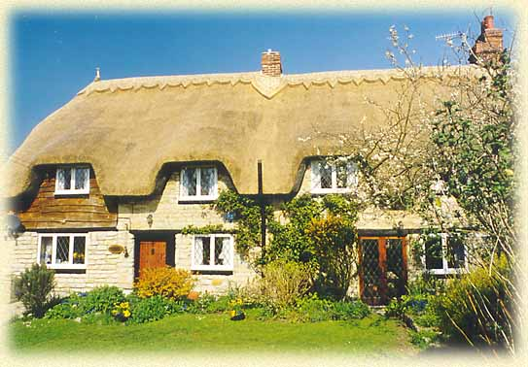
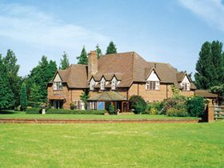

THE COTTAGE PEAR TREE COTTAGE WILLOW CORNER GLEBE FARMHOUSE
EVESHAM WILMCOTE ARMSCOTE LOXLEY

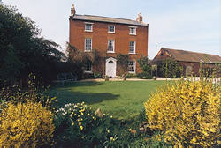
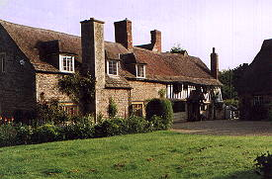
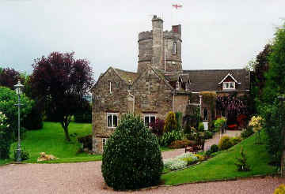
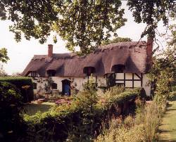

OLD WINDMILL ALDERMINSTER FARM LOXLEY FARM THE OLD MANOR
INKBERROW ALDERMINSTER LOXLEY HALFORD

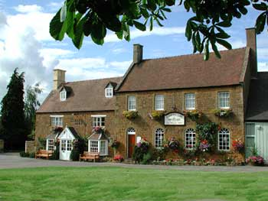
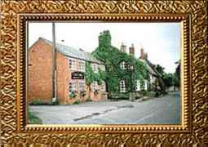
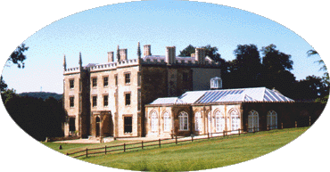
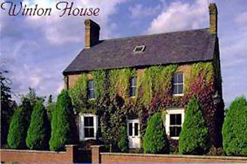

ABBEY MANOR WINTON HOUSE THE FOX AND GOOSE THE HOWARD ARMS
EVESHAM UPPER QUINTON ARMSCOTE ILMINGTON

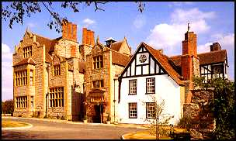
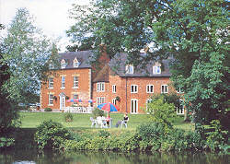
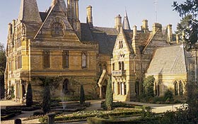
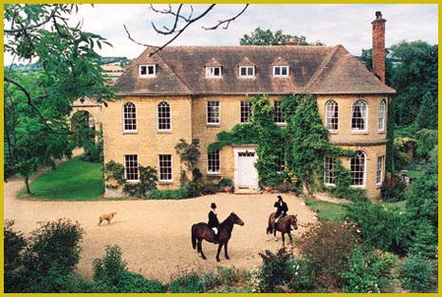

UPPER COURT THE MILL@ HARVINGTON SALFORD HALL ETTINGTON PARK
KEMERTON HARVINGTON ABBOTS SALFORD ETTINGTON

THE COTTAGE, EVESHAM – 17TH Century grade II listed cottage just 800 yards from the River Avon.
3 rooms. Bed and breakfast from £ 25 per person. No smoking. No credit cards.
Tel: +44 1386 443313, Fax: +44 1386 421690, e-mail: klingdex@dial.pipex.com
Further info: www.bed-breakfast-uk.com/bb-uk-he01.htm

PEAR TREE COTTAGE, WILMCOTE – Stylish mid 16th Century yeoman farmers dwelling of immense charm and character.
7 rooms. Bed and breakfast from £ 27 per person. No smoking. No credit cards.
Tel: +44 1789 205889, Fax: +44 1789 262862, e-mail: peartree3@hotmail.com
Further info: www.peartreecot.co.uk

WILLOW CORNER, ARMSCOTE – 300 year old thatched and beamed former smithy.
3 rooms. Bed and breakfast from £ 27 per person. No smoking. No credit cards.
Tel: +44 1608 682391, no fax, e-mail: trish&alan@willowcorner.co.uk
Further info: www.willowcorner.co.uk

GLEBE FARMHOUSE, LOXLEY – Stylish and secluded country house of great charm and character, set in 30 acres of glorious farmland.
4 rooms. Bed and breakfast from £ 50 per person. Restricted smoking facilities. Most major credit cards accepted.
Tel: +44 1789 842501, Fax: +44 1789 841194, e-mail: scorpiolimitede@msn.com
Further info: www.glebefarmhouse.com or www.johansens.com/glebefarmhouse

THE OLD WINDMILL, INKBERROW – Magnificent listed former windmill set in a tranquil 2-acre quarry garden.
3 rooms. Bed and breakfast from £ 45 per person. No smoking. Visa and MasterCard accepted.
Tel: +44 1386 792801, Fax: +44 1386 793762, e-mail: Sheila@theoldwindmill.co.uk
Further info: www.theoldwindmill.co.uk

LOXLEY FARM, LOXLEY – Early 14th Century grade II listed thatched yeoman farmers cottage.
2 rooms. Bed and breakfast from £ 30 per person. No smoking. No credit cards.
Tel: + 44 1789 840265, Fax: +44 1789 840465, no e-mail.
Further info: www.karenbrown.com/england/loxleyfarm.html

THE OLD MANOR, HALFORD – Very pretty 16th Century thatched country house with 17th Century additions.
3 rooms. Bed and breakfast from £ 35 per person. Restricted smoking facilities. No credit cards.
Tel: +44 1789 740264, Fax: +44 1789 740609, e-mail: wpusey@st-philips.co.uk
Further info: www.bath.org/hotel/oldmanor.html or www.bbgl.co.uk/lodgings/301851.html

ABBEY MANOR, EVESHAM – Gothic revival manor set in mature parkland.
2 rooms. Bed and breakfast from £ 36 per person. Restricted smoking facilities. Most major credit cards accepted.
Tel: +44 1386 442437, no fax, e-mail: phipps@abbey-manor.fsnet.co.uk
Further info: www.simon-de-montfort.freeserve.co.uk

WINTON HOUSE, UPPER QUINTON – Charming, beautifully decorated 1856 Victorian farmhouse.
3 rooms. Bed and breakfast from £ 32 per person. No smoking. No credit cards.
Tel: +44 1789 720500, no fax, e-mail: gail@wintonhouse.com
Further info: www.wintonhouse.com

THE FOX AND GOOSE, ARMSCOTE – A stunningly transformed inn of immense, slightly eccentric character. Wonderful food.
4 rooms. Bed and breakfast from £ 45 per person. Restricted smoking facilities. Most major credit cards accepted.
Tel: +44 1608 682293, Fax: same, e-mail: susy.gray@btinternet.com
Further info: www.aboveaverage.co.uk/default2.htm

THE HOWARD ARMS, ILMINGTON – Rambling 17th Century Cotswold’s stone inn set in a quiet village.
3 rooms. Bed and breakfast from £ 39 per person. No smoking in rooms. Most major credit cards accepted.
Tel: +44 1608 682226, Fax: same, e-mail: info@howardarms.com
Further info: www.howardarms.com

UPPER COURT, KEMERTON – Outstanding Georgian manor house in a beautiful location.
5 rooms. Bed and breakfast from £ 42.50 per person. No smoking. Most major credit cards accepted.
Tel: +44 1386 725351, Fax: +44 1386 725472, e-mail: diana@uppercourt.co.uk
Further info: www.uppercourt.co.uk

THE MILL AT HARVINGTON, HARVINGTON – Mid 1700’s former mill, bakery and Georgian house.
21 rooms. Bed and breakfast from £ 45 per person. Restricted smoking facilities. Most major credit cards accepted.
Tel: +44 1386 870686, Fax: same, e-mail: millatharvington@aol.com
Further info: www.s-h-systems.co.uk/a01222.html or www.bestloved.com

SALFORD HALL, ABBOTS SALFORD – Romantic grade I listed manor house, originally built in 1470 as a monastic residence.
33 rooms. Bed and breakfast from £ 59 per person. Restricted smoking facilities. Most major credit cards accepted.
Tel: +44 1386 871300, Fax: +44 1386 871301, e-mail: reception@salfordhall.co.uk
Further info: www.salfordhall.co.uk

ETTINGTON PARK, ETTINGTON – Distinct grade I listed neo-gothic Victorian manor house renowned for it’s superb service.
48 rooms. Bed and breakfast from £ 92.50 per person. Restricted smoking facilities. Most major credit cards accepted.
Tel: +44 1789 450123, Fax: +44 1789 450472, e-mail: info@ettingtonpark.co.uk
Further info: www.ettingtonpark.co.uk

