South Gloucestershire…
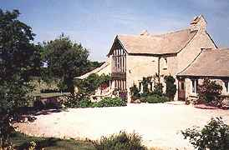
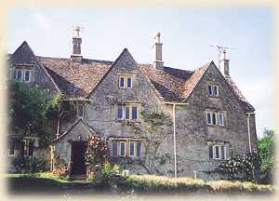
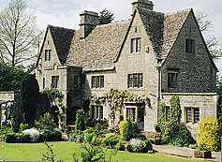
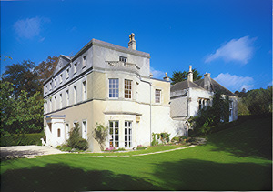

HAMPTON FIELDS HUNTERS LODGE THE OLD HOUSE DUNKIRK MANOR
MEYSEY HAMPTON MINCHINHAMPTON CALMSDEN AMBERLEY
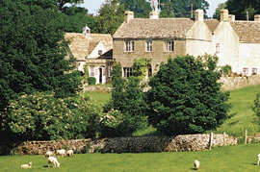
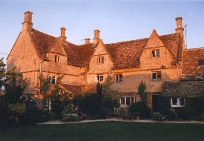
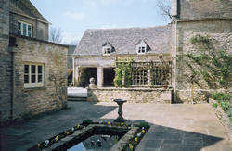
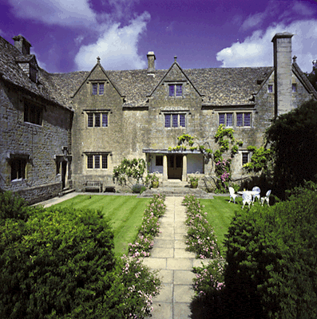

WINSTONE GLEBE CLAPTON MANOR GROVE FARM HOUSE HALEWELL HOUSE
WINSTONE CLAPTON-ON-THE-HILL COLD ASTON WITHINGTON

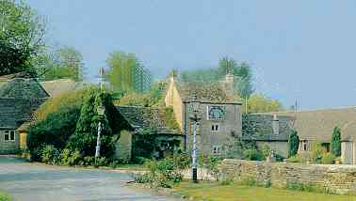
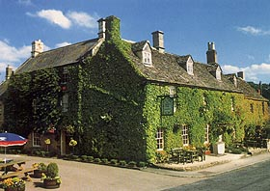
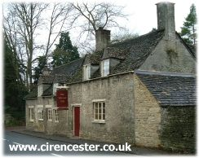
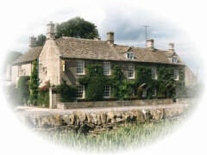

THE WILD DUCK THE VILLAGE PUB INN FOR ALL SEASONS THE NEW INN

EWEN BARNSLEY THE BARRINGTONS COLN ST ALDWYN

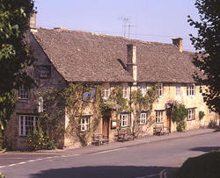
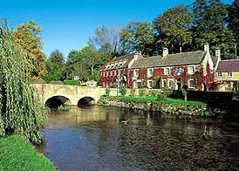
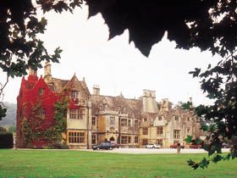
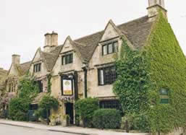

THE LAMB THE BAY TREE THE SWAN HOTEL BIBURY COURT
BURFORD BURFORD BIBURY BIBURY

HAMPTON FIELDS, MEYSEY HAMPTON – A beautiful 19th Century barn conversion covered in Hollyhocks and roses.
3 rooms. Bed and breakfast from £ 32 per person. No smoking. No credit cards.
Tel: +44 1285 850070, Fax: +44 1285 850993, e-mail: richard@hampflds.fsnet.co.uk
Further info: www.bbgl.co.uk/lodgings/300358.html

HUNTERS LODGE, MINCHINHAMPTON – An old Cotswold stone house on the very edge of 600 acres of National Trust woodland.
3 rooms. Bed and breakfast from £ 21 per person. No smoking. No credit cards.
Tel: +44 1453 883588, Fax: +44 1453 731449, no e-mail.
Further info: www.s-h-systems.co.uk/a10707.html or www.tuckedup.com/hunterslodge.html

THE OLD HOUSE, CALMSDEN – 500-year-old stone house in a tiny hamlet.
3 rooms. Bed and breakfast from £ 30 per person. No smoking. No credit cards.

Tel: +44 1285 831240, Fax: same, e-mail: baxter@calmsden.freeserve.co.uk

Further info: www.s-h-systems.co.uk/a54810.html

DUNKIRK MANOR, AMBERLEY – Sublime Grade II listed 17th Century country house with Georgian frontage added circa 1810. Stunning views.
6 rooms. Bed and breakfast from £ 37.50 per person. No smoking. Most major credit cards accepted.
Tel: +44 1453 873456, Fax: +44 1453 878518, e-mail: info@dunkirkmanor.com
Further info: www.dunkirkmanor.com

WINSTONE GLEBE, WINSTONE – Small early 19th Century Georgian rectory set in 5 acres of gardens and paddocks.
3 rooms. Bed and breakfast from £ 30 per person. Restricted smoking facilities. Visa and MasterCard accepted.
Tel: +44 1285 821451, Fax: same, e-mail: sparsons@winstoneglebe.com

CLAPTON MANOR, CLAPTON ON THE HILL – Wonderful 16th and 17th Century Cotswold’s stone manor house.
2 rooms. Bed and breakfast from £35 per person. No smoking. Visa and MasterCard accepted.
Tel: +44 1451 810202, Fax: +44 1451 821804, e-mail: bandb@claptonmanor.co.uk
Further info: www.karenbrown.com/england/clapton.html or www.bbgl.co.uk/lodgings/300360.html

GROVE FARM HOUSE, COLD ASTON – 18TH Century farmhouse with lovely views.
3 rooms. Bed and breakfast from £ 35 per person. No smoking. No credit cards.
Tel: +44 1451 821801, Fax: +44 1451 821108, e-mail: angela@cotswoldbedandbreakfast.com
Further info: www.sawdays.co.uk

HALEWELL, WITHINGTON – Enchanting stone manor house with many original features.
6 rooms. Bed and breakfast from £ 44.50 per person. Restricted smoking facilities. Most major credit cards accepted.
Tel: +44 1242 890238, Fax: +44 1242 890332, no e-mail.
Further info: www.information-britain.co.uk/s/E356.htm

THE WILD DUCK, EWEN – A characterful Inn built in Elizabethan times and a long standing favourite.
11 rooms. Bed and breakfast from £ 40 per person. . Restricted smoking facilities. Most major credit cards accepted.

Tel: +44 1285 770310, Fax: +44 1285 770924, e-mail: wduckinn@aol.com
Further info: www.s-h-systems.co.uk/a03816.html

THE VILLAGE PUB, BARNSLEY – A very traditional Cotswold village local given a subtle modern twist.
6 rooms. Bed and breakfast from £ 40 per person. . Restricted smoking facilities. Most major credit cards accepted.

Tel: +44 1285 740421, Fax: +44 1285 740412, e-mail: info@thevillagepub.co.uk

Further info: www.thevillagepub.co.uk

INN FOR ALL SEASONS, THE BARRINGTONS – Engaging Grade II listed 16th Century country inn, formerly a mansion.
10 rooms. Bed and breakfast from £ 44.50 per person. Restricted smoking facilities. Most major credit cards accepted.
Tel: +44 1451 844324, Fax: +44 1451 844375, e-mail: sharp@innforallseasons.com
Further info@www.innforallseasons.com

THE NEW INN AT COLN, COLN ST ALDWYN – Atmospheric, creeper clad 16th Century Inn (2002 Inn of the Year)
14 rooms. Bed and breakfast from £ 55 per person. Restricted smoking facilities. Most major credit cards accepted.
Tel: +44 1285 750651, Fax: +44 1285 750657, e-mail: stay@new-inn.co.uk
Further info: www.new-inn.co.uk

THE LAMB, BURFORD – Famous Cotswold’s hostelry. An archetypal English coaching inn with 15th Century roots.
15 rooms. Bed and breakfast from £ 52.50 per person. Restricted smoking facilities. Most major credit cards accepted.
Tel: +44 1993 823155, Fax: +44 1993 822228, no e-mail.
Further info: www.heavenlyhotels.co.uk/lamb.htm

THE BAY TREE, BURFORD – Gorgeous Tudor manor house, visited by Queen Elizabeth I, set in a beautiful small town.
23 rooms. Bed and breakfast from £ 72.50 per person. Restricted smoking facilities. Most major credit cards accepted.
Tel: +44 1993 822791, Fax: +44 1993 823008, no e-mail.
Further info: www.broadway-cotswolds.co.uk/baytree.html

THE SWAN HOTEL, BIBURY – Historic hotel, built in the 1630’s, in one of the Cotswold’s prettiest villages.
23 rooms. Bed and breakfast from £ 90 per person. Restricted smoking facilities. Most major credit cards accepted.
Tel: +44 1285 740695, Fax: +44 1285 740473, e-mail: swanhot1@swanhotel-cotswolds.co.uk
Further info: www.swanhotel.co.uk

BIBURY COURT, BIBURY – Gracious Tudor mansion, built in 1633 and visited by king Charles II.
18 rooms. Bed and breakfast from £ 70 per person. Restricted smoking facilities. Most major credit cards accepted.
Tel: +44 1285 740337, Fax: +44 1285 740660, e-mail: info@biburycourt.co.uk
Further info: www.biburycourt.co.uk

