South Devon…
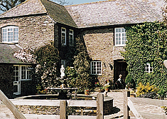
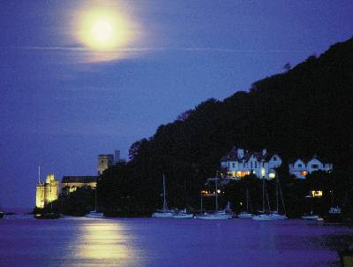
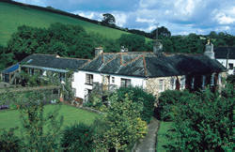
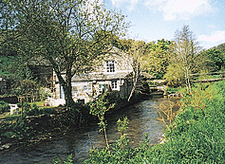

BROOME COURT FINGALS CROWDY MILL GUNFIELD HOTEL
DARTMOUTH DITTISHAM HARBERTON DARTMOUTH

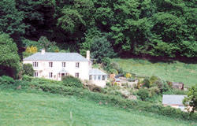
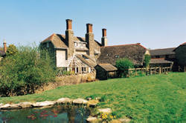
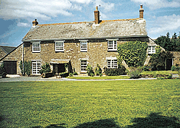
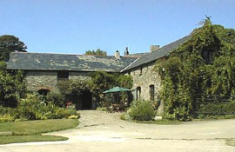

LOWER STADBURY LOWER GRIMPSTONLEIGH WOODSIDE COTTAGE MANOR FARM
AVETON GIFFORD EAST ALLINGTON BLACKAWTON BROADHEMPSTON

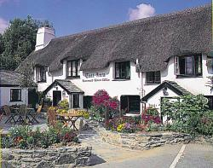
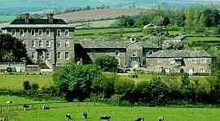
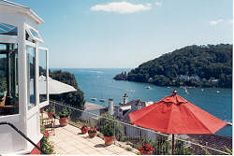
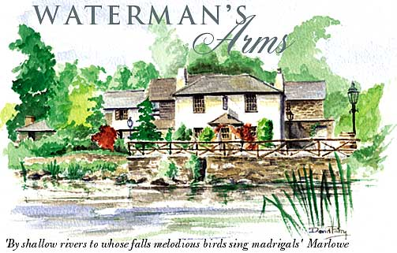

KINGSTON HOUSE NONSUCH HOUSE THE COTT INN WATERMAN’S ARMS
STAVERTON KINGSWEAR DARTINGTON ASHPRINGTON
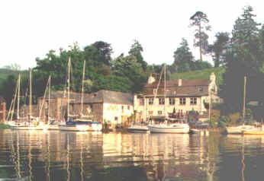
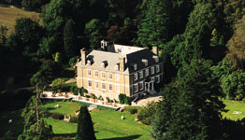
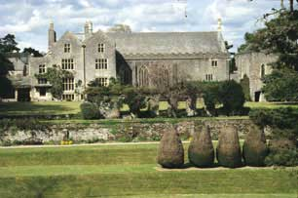
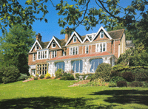

THE MALTSERS ARMS DARTINGTON HALL ORESTONE MANOR BUCKLAND TOUT SAINTS
TUCKENHAY DARTINGTON MAIDENCOMBE GOVETON

BROOME COURT, DARTMOUTH – Old farm buildings surrounding a pretty courtyard.
4 rooms. Bed and breakfast from £ 35 per person. Restricted smoking facilities. No credit cards.
Tel: +44 1803 834275, Fax: +44 1803 833260, no e-mail.
Further info: www.4hotels.co.uk/uk/hotels/broome.html

FINGALS, DITTISHAM – Wonderful country house in an outstanding location, and with a wonderful house party atmosphere.
9 rooms. Bed and breakfast from £ 35 per person. Restricted smoking facilities. Most major credit cards accepted.
Tel: +44 1803 722398, Fax: +44 1803 722401, e-mail: richard@fingals.co.uk
Further info: www.fingals.co.uk

TAILRACE AT CROWDYMILL, HARBERTON – Charming 18th Century grade II listed cottage on the banks of the river Harbourne.
3 rooms. Bed and breakfast from £ 23 per person. No smoking. No credit cards.
Tel: +44 1803 732340, Fax: same, e-mail: info@crowdymill.co.uk
Further info: www.crowdymill.co.uk

THE GUNFIELD HOTEL, DARTMOUTH – Charming small hotel in an idyllic setting with wonderful views over the River Dart.
10 rooms. Bed and breakfast from £ 30 per person. Restricted smoking facilities. Most major credit cards accepted.
Tel: +44 1803 834571, Fax: +44 1803 834772, e-mail: enquiry@gunfield.co.uk
Further info: www.gunfield.co.uk

LOWER STADBURY, AVETON GIFFORD – Listed manor house tucked away in leafy countryside.
3 rooms. Bed and breakfast from £ 22.50 per person. Restricted smoking facilities. No credit cards.
Tel: +44 1548 852159, Fax: same, no e-mail.
Further info: www.tuckedup.com/lowerstadbury.html

LOWER GRIMPSTONLEIGH, EAST ALLINGTON – Old stone farmstead set amongst orchards and meadows.
2 rooms. Bed and breakfast from £ 26 per person. No smoking. No credit cards.
Tel: +44 1548 521258, Fax: same, e-mail: grimpstonleigh@ukgateway.net
Further info: www.grimpstonleigh.com

WOODSIDE COTTAGE, BLACKAWTON – 18th century gamekeepers’ cottage.
3 rooms. Bed and breakfast from £ 25 per person. No smoking. No credit cards.
Tel: +44 1803 712375, no fax, e-mail: b&b@woodsidedartmouth.co.uk
Further info: www.woodsidedartmouth.co.uk

MANOR FARM, BROADHEMPSTON – Elegant part 14th Century Devon farmhouse of immense character.
2 rooms. Bed and breakfast from £ 24 per person. No smoking. No credit cards.
Tel: +44 1803 813260, Fax: same, e-mail: clappfamily@members.shines.net
Further info: www.sawdays.co.uk

KINGSTON HOUSE, STAVERTON – Early 18th Century manor house majestically situated at the heart of the private Kingston estate.
3 rooms. Bed and breakfast from £ 65 per person. Restricted smoking facilities. Most major credit cards accepted.
Tel: +44 1803 762235, Fax: +44 1803 762444, e-mail: info@kingston-estate.co.uk
Further info: www.kingston-estate.co.uk

NONSUCH, KINGSWEAR – Wonderfully positioned small hotel on the mouth of the river dart with views over to Dartmouth town.
5 rooms. Bed and breakfast from £ 35 per person. Restricted smoking facilities. Most major credit cards accepted.
Tel: +44 1803 752829, Fax: +44 1803 752357, e-mail: enquiries@nonsuch-house.co.uk
Further info: www.nonsuch-house.co.uk

THE COTT INN, DARTINGTON – Stone and cob built pub with a wonderful thatched roof. In continuous license since 1320.
6 rooms. Bed and breakfast from £ 35 per person. Restricted smoking facilities. Most major credit cards accepted.
Tel: +44 1803 863777, Fax: +44 1803 866629, no e-mail.
Further info: www. www.oldenglish.co.uk/pubs/p3.asp

THE WATERMANS ARMS, ASHPRINGTON – Famous country inn set in splendid isolation at the head of the heavily wooded Bow creek.
15 rooms. Bed and breakfast from £ 27.50 per person. Restricted smoking facilities. Most major credit cards accepted.
Tel: +44 1803 732214, Fax: +44 1803 732314, e-mail: steven@simmonss.fsnet.co.uk
Further info: www.devon-connect.co.uk/hotel/watermans/index.html

THE MALTSTERS ARMS, TUCKENHAY – Outstanding pub in a marvelous location next to a peaceful wooded creak. Fantastic bedrooms.
7 rooms. Bed and breakfast from £ 25 per person. Restricted smoking facilities. Most major credit cards accepted.
Tel: +44 1803 732350, Fax: +44 1803 732823, e-mail: pub@tuckenhay.demon.co.uk
Further info: www. www.tuckenhay.com

DARTINGTON HALL, DARTINGTON – Fabulous grade I listed manor house built in 1388 for Richard II’s half brother.
40 rooms. Bed and Breakfast from £ 42.50 per person. No smoking in rooms. Most major credit cards accepted.
Tel: +44 1803 847100, Fax: +44 1803 847101, e-mail: bookings@dartingtonhall.com
Further info: www.dartingtonhall.com

ORESTONE MANOR, MAIDENCOMBE – Victorian country house with an air of colonialism and stunning views.
12 rooms. Bed and breakfast from £ 52 per person. No smoking facilities. All major credit cards accepted.
Tel: +44 1803 328098, Fax: +44 1803 328336, e-mail: enquiries@orestone.co.uk
Further info: www.orestone.co.uk

BUCKLAND TOUT SAINTS, GOVETON – Impeccable 300-year-old William and Mary manor house.
14 rooms. Bed and breakfast from £ 65 per person. Restricted smoking facilities. Most major credit cards accepted.
Tel: +44 1548 853055, Fax: +44 1548 856261, e-mail: buckland@tout-saints.co.uk
Further info: www. www.tout-saints.co.uk

