Oxfordshire…
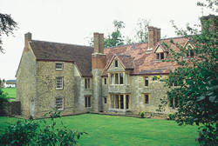
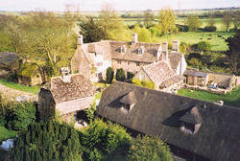
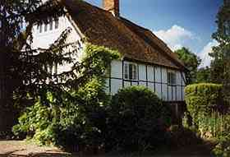
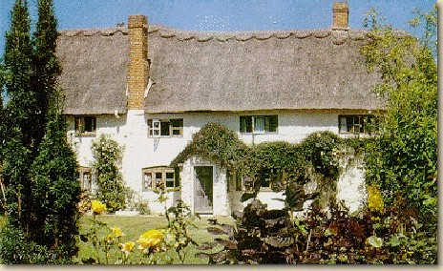

THE MANOR HOUSE ROOKS ORCHARD RECTORY FARM THE CRAVEN
STADHAMPTON LITTLE WITTENHAM NORTHMOOR UFFINGTON

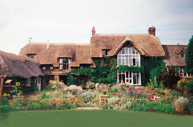
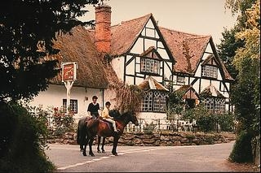
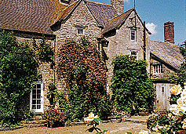
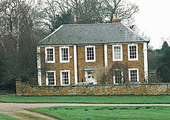

HOME FARMHOUSE GOWERS CLOSE OLD RECTORY THE WHITE HORSE
CHARLTON SIBFORD GOWER WARMINGTON WOOLSTONE

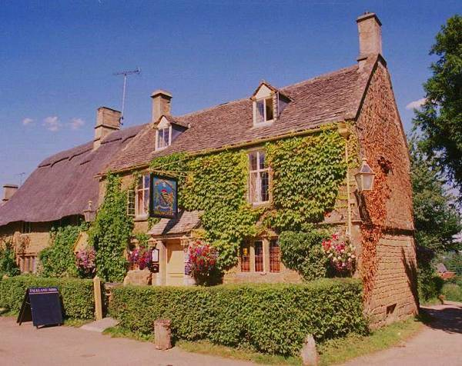
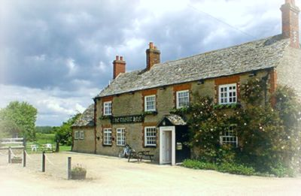
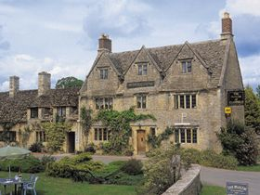
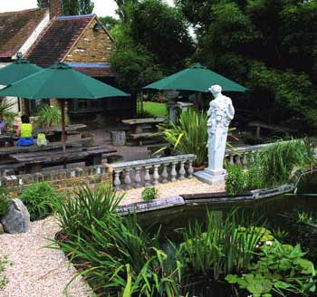

THE TROUT INN THE FALKLAND ARMS THE PLOUGH HOTEL THE CRAZY BEAR
TADPOLE BRIDGE GREAT TEW CLANFIELD STADHAMPTON

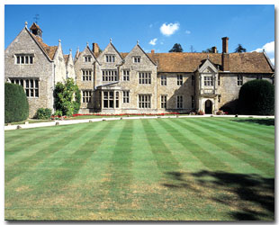
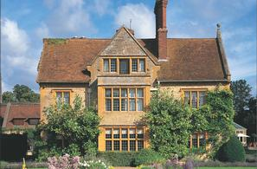
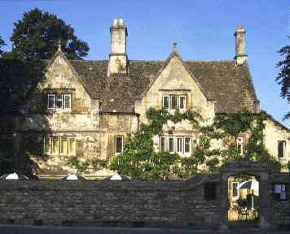
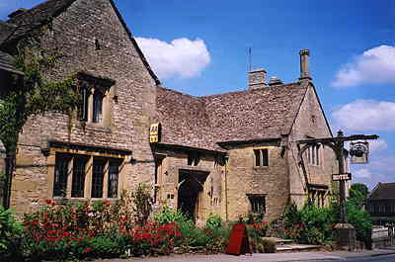

OLD PARSONAGE THE SHAVEN CROWN STUDLEY PRIORY MANOIR AUX QUAT’ SAISONS
OXFORD SHIPTON UNDER WYCHWOOD HORTON-CUM-STUDLEY GREAT MILTON

THE MANOR HOUSE, STADHAMPTON – Ravishing, ancient stone manor house of great architectural interest.
3 rooms. Bed and breakfast from £ 40 per person. No smoking. No credit cards.
Tel: +44 1865 891999, Fax: +44 1865 891640, e-mail: action@timebeam.com
Further info not available at this time.

ROOKS ORCHARD, LONG WITTENHAM – Historic 17th Century house surrounded by lovely gardens and orchards.
2 rooms. Bed and breakfast from £ 25 per person. No smoking. No credit cards.
Tel: +44 1865 407765, Fax: same, no e-mail.
Further info: www.information-britain.co.uk/s/E149.htm

RECTORY FARM, NORTHMOOR – 16th Century farmhouse on a working farm once owned by St Johns College in Oxford.
2 rooms. Bed and breakfast from £ 25 per person. No smoking. No credit cards.
Tel: +44 1865 300207, Fax: +44 1865 300569, e-mail: pj.florey@farmline.com
Further info: www.oxtowns.co.uk/rectoryfarm/

THE CRAVEN, UFFINGTON – Charming Rose and Clematis covered 17th Century thatched cottage.
6 rooms. Bed and breakfast from £ 27.50 per person. Restricted smoking facilities. Visa and MasterCard accepted.
Tel: +44 1367 820449, no fax, e-mail: carol@thecraven.co.uk
Further info: www.thecraven.co.uk

HOME FARMHOUSE, CHARLTON - 400 year old Cotswold stone house (Grade II) looking out onto a flagged courtyard of roses, begonias and clematis.
3 rooms. Bed and breakfast from £ 32 per person. No smoking. Most major credit cards accepted.
Tel: +44 1295 811683, Fax: same, e-mail: grovewhite@lineone.net
Further info: www.homefarmhouse.co.uk

GOWERS CLOSE, SIBFORD GOWER – 17TH Century thatched and beamed village house full of character.
2 rooms. Bed and breakfast from £ 25 per person. Restricted smoking facilities. No credit cards.
Tel: +44 1295 780348, no fax, no e-mail.
Further info: www.europetraditions.com/england/int/442.html

THE OLD RECTORY, WARMINGTON – Grade II listed 18th Century Rectory set on the green in a quiet village.
3 rooms. Bed and breakfast from £ 25 per person. No smoking. No credit cards.
Tel: +44 1295 690531, Fax: +44 1295 690526, e-mail: sirwhcockcroft@clara.co.uk
Further info: www.s-h-systems.co.uk/a13108.html or www.tuckedup.com/oldrectoryoxford.html

THE WHITE HORSE, WOOLSTONE – Attractive beamed and thatched 16th Century village Inn.
6 rooms. Bed and breakfast from £ 32.50 per person. Restricted smoking facilities. Most major credit cards accepted.
Tel: +44 1367 820726, Fax: +44 1367 820566, e-mail: whorseuffington@aol.com
Further info: www.whitehorsewoolstone.co.uk

THE TROUT INN, TADPOLE BRIDGE – Delightfully named 17th Century pub on the banks of the upper River Thames.
6 rooms. Bed and breakfast from £ 40 per person. Restricted smoking facilities. Most major credit cards accepted.
Tel: +44 1367 870382, no fax, e-mail: info@trout-inn.co.uk
Further info: www.trout-inn.co.uk

THE FALKLAND ARMS, GREAT TEW – A classic gem. 500 year old thatched and creeper clad Inn in an unspoilt and tranquil village.
6 rooms. Bed and breakfast from £ 32.50 per person. Restricted smoking facilities. Most major credit cards accepted.
Tel: +44 1608 683653, Fax: +44 1608 683656, e-mail: sjcourage@btconnect.com
Further info: www.falklandarms.org.uk

THE PLOUGH, CLANFIELD – 16TH Century manor house of high regard. Elizabethan architecture at it’s finest.
12 rooms. Bed and breakfast from £ 57.50 per person. No smoking. Most major credit cards accepted.
Tel: +44 1367 810222, Fax: +44 810596, e-mail: ploughatclanfield@hotmail.com
Further info: www.theaa.com/hotels/77772.html

THE CRAZY BEAR, STADHAMPTON – Rural 16th Century inn given a recent flamboyant refurbishment. Intriguing!
12 rooms. Bed and breakfast from £ 40 per person. Restricted smoking facilities. Most major credit cards accepted.
Tel: +44 1865 890714, Fax: +44 1865 400481,e-mail: sales@crazybearhotel.co.uk
Further info: www.crazybearhotel.co.uk

THE OLD PARSONAGE, OXFORD – 17th Century townhouse set in tranquil gardens on the edge of Oxford’s city center. Oscar Wilde slept here.
30 rooms. Bed and breakfast from £ 77.50 per person. Restricted smoking facilities. Most major credit cards accepted.
Tel: +44 1865 310210, Fax: +44 1865 311262, e-mail: info@oldparsonage-hotel.co.uk
Further info: www.oldparsonage-hotel.co.uk

THE SHAVEN CROWN, SHIPTON UNDER WYCHWOOD – 14TH century grade II listed former monk’s hospice built around an attractive courtyard.
8 rooms. Bed and breakfast from £ 47.50 per person. Restricted smoking facilities. Visa and MasterCard accepted.
Tel: +44 1993 830330, Fax: +44 1993 832136, no e-mail.
Further info: www.shavencrown.co.uk

STUDLEY PRIORY, HORTON CUM STUDLEY – 12th Century manor house, built originally as a Benedictine Nunnery, standing in 13 acres of wooded grounds.
18 rooms. Bed and breakfast from £ 82.50 per person. Restricted smoking facilities. Most major credit cards accepted.
Tel: +44 1865 351203, Fax: +44 1865 351613, e-mail: res@studley-priory.co.uk
Further info: www.studley-priory.co.uk

LE MANOIR AUX QUAT’ SAISON, GREAT MILTON – The ultimate in luxury. 15th century manor house with outstanding cuisine. Truly sublime.
32 rooms. Bed and breakfast from £ 122.50 per person. Restricted smoking facilities. Most major credit cards accepted.
Tel: +44 1844 278881, Fax: +44 1844 278847, e-mail: lemanoir@blanc.co.uk
Further info: www.manoir.com

