Herefordshire…

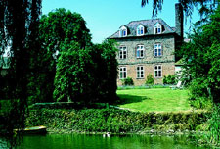
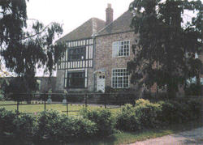
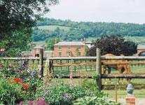
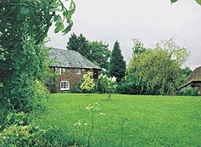

HALLEND LITTLE MARCLE COURT LOWER BACHE GROVE HOUSE
KYNASTON MUCH MARCLE KIMBOLTON BROMSBERROW HEATH

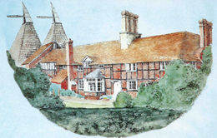
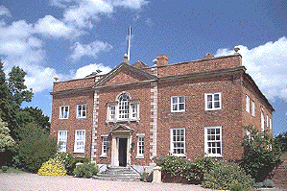
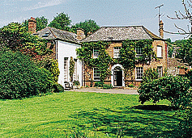
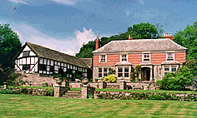

WELLAND COURT BOLLINGHAM HOUSE MOOR COURT FARM GUNN MILL HOUSE UPTON-UPON-SEVERN EARDISLEY STRETTON GRANDISON MITCHELDEAN
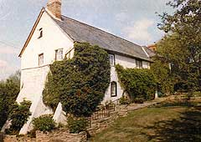
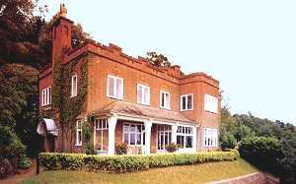
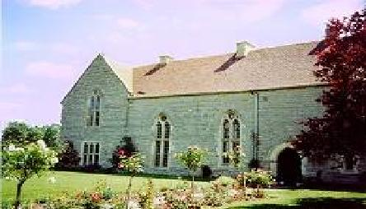
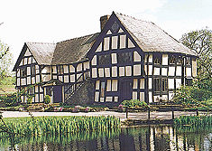

WYCHE KEEP ASHLEWORTH COURT THE VAULD FARMHOUSE THE STEPPES

MALVERN WELLS ASHLEWORTH MARDEN ULLINGSWICK

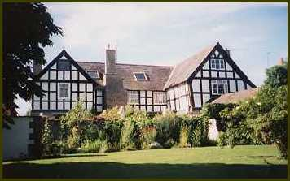
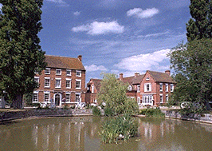
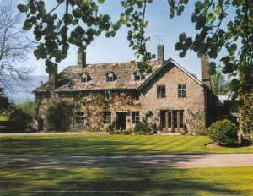
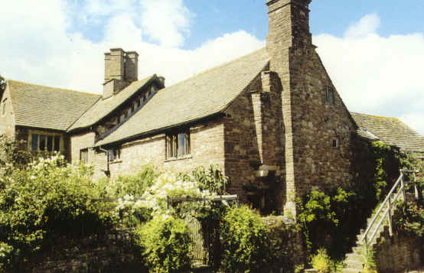

WINFORTON COURT ALLT-YR-YNYS PENYCLAWDD COURT CORSE LAWN HOUSE
WINFORTON WALTERSTONE LLANFIHANGEL CRUCORNEY CORSE LAWN

HALLEND, KYNASTON – Georgian country house set in the middle of a well-known equestrian estate with far reaching views.
3 rooms. Bed and breakfast from £ 37.50 per person. No smoking. Visa and MasterCard accepted.
Tel: +44 1531 670225, Fax: +44 1531 670747, e-mail: khjefferson@hallend.freeserve.co.uk
Further info: www.karenbrown.com/england/hallend.html or www.europetraditions.com/england/int/460.html

LITTLE MARCLECOURT, LITTLE MARCLE – Stunning country house in beautiful grounds, built for the Lord lieutenant of Herefordshire in 1590.
3 rooms. Bed and breakfast from £ 20 per person. No smoking. No credit cards.
Tel: +44 1531 670936, no fax, no e-mail.
Further info: www.ledbury.net/business/littlemarcle/index.html

LOWER BACHE, KIMBOLTON – Award winning 17th century country house set in fourteen acres of nature reserve.
4 rooms. Bed and breakfast from £ 29.50 per person. No smoking. Most major credit cards accepted.
Tel: +44 1568 750304, no fax, e-mail: leslie.wiles@care4free.net
Further info: www.sawdays.co.uk or www.s-h-systems.co.uk/hotels/lowerbache.html

GROVE HOUSE, BROMSBERROW HEATH – Glorious house of 12th Century origins with 18th Century additions.
6 rooms. Bed and breakfast from £ 36.50 per person. Restricted smoking facilities. No credit cards.
Tel: +44 1531 650584, no fax, no e-mail.
Further info: www.sawdays.co.uk or www.bromsberrow.org.uk/grove2.html

WELLAND COURT, UPTON UPON SEVERN – Small 15th Century manor house of great charm and character hidden behind an 18th Century Georgian façade.
3 rooms. Bed and breakfast from £ 35 per person. Restricted smoking facilities. No credit cards.
Tel: +44 1684 594426, Fax: same, e-mail: archer@wellandcourt.freeserve.co.uk
Further info: www.mistral.co.uk/hammerwood/welland.htm or www.s-h-systems.co.uk/a42882.html

BOLLINGHAM HOUSE, EARDISLEY – 14TH century manor house full of sybaritic charm and comfort.
3 rooms. Bed and breakfast from£ 29 per person. Restricted smoking facilities. No credit cards.
Tel: +44 1544 327326, Fax: +44 1544 327880, e-mail: bollhouse@bigfoot.com
Further info: www.sawdays.co.uk or www.tuckedup.com/bollinghamhouse.html

MOOR COURT FARM, STRETTON GRANDISON – Stunning medieval farmhouse set in beautiful gardens on a working farm.
3 rooms. Bed and breakfast from £ 20 per person. No smoking. No credit cards.
Tel: + 1531 670408, Fax: +44 1531 670408, no e-mail.
Further info: www.ledbury.net/business/moorcourt/

GUNN MILL HOUSE, MITCHELDEAN – 1700’s Georgian country house set in 5 rural acres of the Forest of Dean.
8 rooms. Bed and breakfast from £ 25 per person. No smoking. Most major credit cards accepted.
Tel: +44 1594 827577, Fax: same, e-mail: info@gunnmillhouse.co.uk
Further info: www.gunnmillhouse.co.uk

WYCHE KEEP, MALVERN WELLS – Historic Arts and Crafts style country house with sweeping 60-mile views.
3 rooms. Bed and breakfast from £ 30 per person. No smoking. No credit cards.
Tel: +44 1684 567018, Fax: +44 1684 892304, e-mail: wychekeep@aol.com
Further info: www.jks.org/wychekeep/ or www.milford.co.uk/england/accom/h-a-3400.html

ASHLEWORTH COURT, ASHLEWORTH – 15TH century manor house on a working farm adjacent to a medieval church and tithe barn.
5 rooms. Bed and breakfast from £ 22 per person. No smoking. No credit cards.
Tel: +44 1452 700241, Fax: +44 1452 700411, e-mail: chamberlayne@farmline.com
Further info: www.s-h-systems.co.uk/a54701.html

THE VAULD FARMHOUSE, MARDEN – Beautiful black-and-white timbered Elizabethan manor house.
3 rooms. Bed and breakfast from £ 25 per person. Restricted smoking facilities. No credit cards.
Tel: +44 1568 797898, no fax, no e-mail.
Further info: www.tuckedup.com/thevauldfarm.html

THE STEPPES, ULLINGSWICK – Grade II listed 400-year-old Yeoman’s house with a much-acclaimed restaurant.
6 rooms. Bed and breakfast from £ 40 per person. No smoking. Most major credit cards accepted.
Tel: +44 1432 820424, Fax: +44 1432 820042, e-mail: info@steppeshotel.co.uk
Further info: www.steppeshotel.co.uk

WINFORTON COURT, WINFORTON – Breathtaking manor house, mostly from 1500, set in the beautiful Wye valley.
3 rooms. Bed and breakfast from £ 27per person. Restricted smoking facilities. No credit cards.
Tel: +44 1544 328498, Fax: +44 1544 328498, e-mail: winfortoncourt@talk21.com
Further info: www.s-h-systems.co.uk/a11050.html

ALLT YR YNYS, WALTERSTONE – Medieval 16th Century manor house set in the foothills of the majestic Black mountains.
19 rooms. Bed and breakfast from £ 52.50 per person. Restricted smoking facilities. Most major credit cards accepted.
Tel: +44 1873 890307, Fax: +44 1873 890539, e-mail: reception@alltyrynys.co.uk
Further info: www.allthotel.co.uk

PENYCLAWDD COURT, LLANFIHANGEL CRUCORNEY – Award winning Grade I listed medieval manor house.
5 rooms. Bed and breakfast from £ 45 per person. Restricted smoking facilities. Most major credit cards accepted.
Tel: +44 1873 890719, Fax: +44 1873 890848, e-mail: enquiries@1stmanorhouse.co.uk
Further info: www.1stmanorhouse.co.uk

CORSE LAWN HOUSE, CORSE LAWN – Graceful grade II listed 18th Century Queen Anne house overlooking the village green and duck pond.
19 rooms. Bed and breakfast from£ 50 per person. Restricted smoking facilities. Most major credit cards accepted.
Tel: +44 1452 780771, Fax: +44 1452 780840, e-mail: enquiries@corselawn.com
Further info: www.corselawn.com

