Somerset (Exmoor)…

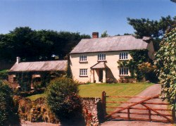
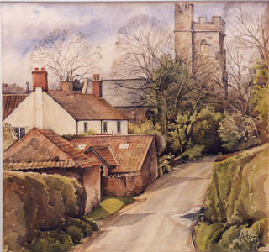
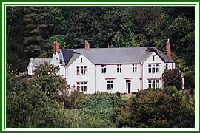
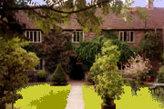

PARSONAGE FARM CUTTHORNE THE OLD PRIORY EDGCOTT HOUSE
OVER STOWEY LUCKWELL BRIDGE DUNSTER EXFORD

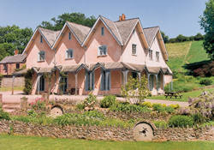
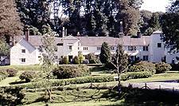
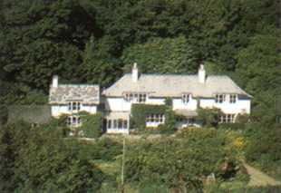
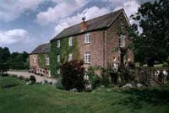

HOOKS HOUSE SIMONSBATH HOUSE LARCOMBE FOOT CURDON MILL

CROWCOMBE SIMONSBATH WINSFORD WILLITON

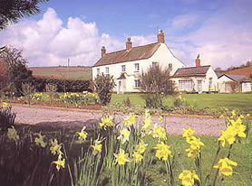
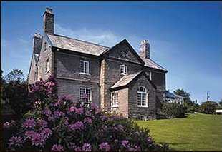
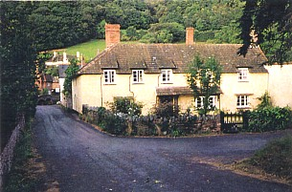
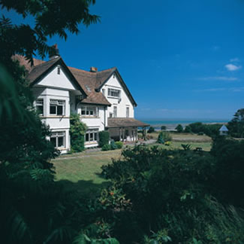

LANGLEY HOUSE HIGHERCOMBE CROSS LANE HOUSE PORLOCK VALE HOUSE
LANGLEY MARSH DULVERTON ALLERFORD PORLOCK VALE

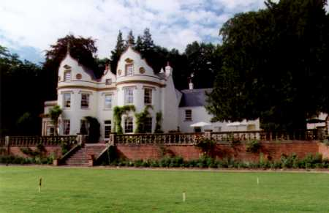
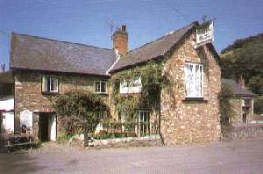
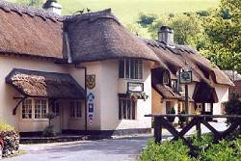
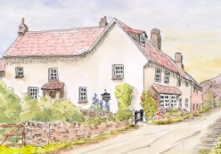

FERN COTTAGE ROYAL OAK ROYAL OAK BINDON HOUSE
ALLERFORD LUXBOROUGH WINSFORD LANGFORD BUDVILLE

PARSONAGE FARM, OVER STOWEY – 17th Century farmhouse set in a walled garden deep in the Quantock hills.
2 rooms. Bed and breakfast from £ 20 per person. No smoking. No credit cards.
Tel: +44 1278 733237, Fax: +44 1278 733511, e-mail: suki@parsonfarm.co.uk
Further info: www.parsonfarm.co.uk

CUTTHORNE, LUCKWELL BRIDGE – A delightful country house tucked away in 25 acres of private valley.
3 rooms. Bed and breakfast from£ 28 per person. No smoking. Most major credit cards accepted.
Tel: +44 1643 831255, Fax: same, e-mail: durbin@cutthorne.co.uk
Further info: www.cutthorne.co.uk

THE OLD PRIORY, DUNSTER – Built by Benedictine monks in the 12th century, this lovely property stands in a pretty walled garden.
3 rooms. Bed and breakfast from £ 32.50per person. No smoking. No credit cards.
Tel: +44 1643 821540, no fax, no e-mail
Further info: www.essentialexmoor.co.uk/staying/hotelsbbsduns.htm or www.s-h-systems.co.uk/a12423.html

EDGCOTT HOUSE, EXFORD – Rambling country house set in secluded gardens.
3 rooms. Bed and breakfast from £ 22 per person. Restricted smoking facilities. Most major credit cards accepted.
Tel: +44 1643 831495, Fax: same, e-mail: enquiries@edgcotthouse.co.uk
Further info: www.edgcotthouse.co.uk

HOOKS HOUSE, CROWCOMBE – Unusual and romantic folly built in the 1830’s.
2 rooms. Bed and breakfast from £ 22.50 per person. No smoking. No credit cards.
Tel: +44 1984 618691, Fax: +44 1984 618357, e-mail: lukemacdd@hookhouse.fsnet.co.uk
Further info: www.sawdays.co.uk

SIMONSBATH HOUSE, SIMONSBATH – A glorious 300 year old country house with outstanding views.
7 rooms. Bed and breakfast from £ 40 per person. Restricted smoking facilities. Most major credit cards accepted.
Tel: +44 1643 831259, Fax: +44 1643 831557, e-mail: hotel@simonsbathhouse.co.uk
Further info: www.s-h-systems.co.uk/hotels/simonsbath.html

LARCOMBE FOOT, WINSFORD – Period house set next to one of Exmoor’s prettiest villages in the tranquil Exe valley.
5 rooms. Bed and breakfast from £ 23 per person. No smoking. No cards.
Tel: +44 1643 851306, Fax: same, e-mail: larcombefoot@talk21.com
Further info: www.exmoor-holidays.co.uk/larcombefoot.html

CURDON MILL, WILLITON - A lovely working water mill situated on farmland at the foot of the beautiful Quantock Hills.
6 rooms. Bed and breakfast from £ 35 per person. Restricted smoking facilities. Most major credit cards accepted.
Tel: +44 1984 656522, Fax: +44 1984 656606, e-mail: davidcroxton@btinternet.com
Further info: www.s-h-systems.co.uk/a12520.html

LANGLEY HOUSE, LANGLEY MARSH – 16TH Century country house.
8 rooms. Bed and breakfast from £ 50 per person. Restricted smoking facilities. Most major credit cards accepted.
Tel: +44 1984 623318, Fax: +44 1984 624573, e-mail: info@langleyhousehotel.co.uk
Further info: www.langleyhousehotel.co.uk

HIGHERCOMBE, DULVERTON – Georgian grade II listed former hunting lodge set in 8 acres of parkland.
3 rooms. Bed and breakfast from £ 35 per person. No smoking. Most major credit cards accepted.
Tel: +44 1398 323451, Fax: same, e-mail: highercombe@btconnect.com
Further info: www.highercombe.co.uk

CROSS LANE HOUSE, ALLERFORD – 15TH Century former farmhouse set on the edge of the village.
3 rooms. Bed and breakfast from £ 18 per person. No smoking. No credit cards.
Tel: +44 1643 862112, no fax, no e-mail.
Further info: www.porlock.co.uk/Members/CrossLane.htm

PORLOCK VALE HOUSE, PORLOCK VALE – superbly run small country house in a stunning coastal location.
15 rooms. Bed and breakfast from £ 45 per person. No smoking facilities. Most major credit cards accepted.
Tel: +44 1643 862338, Fax: +44 1643 863338, e-mail: info@porlockvale.co.uk
Further info: www.porlockvale.co.uk

FERN COTTAGE, ALLERFORD – 16th Century cottage in the heart of this tiny National Trust village.
3 rooms. Bed and breakfast from £ 29 per person. No smoking. Most major credit cards accepted.
Tel: +44 1643 862215, Fax: same, e-mail: ferncottage@bushinternet.com
Further info: www.porlock.co.uk/Members/Fern.html

THE ROYAL OAK, LUXBOROUGH – Rambling rural inn of immense character. Fantastic food and ambience.
12 rooms. Bed and breakfast from £ 27.50 per person. Restricted smoking facilities. Most major credit cards accepted.
Tel: +44 1984 640319, Fax: +44 1984 641561, e-mail: royaloakof_luxborough@virgin.net
Further info: www.s-h-systems.co.uk/a51394.html

THE ROYAL OAK, WINSFORD – Stunning thatched up-market pub in a pretty village, originally a 12th Century cottage.
8 rooms. Bed and breakfast from £ 69 per person. Restricted smoking facilities. All major credit cards accepted.
Tel: +44 1643 851455, Fax: +44 1643 851009, e-mail: enquiries@royaloak-somerset.co.uk
Further info: www.royaloak-somerset.co.uk

BINDON HOUSE, LANGFORD BUDVILLE – A stunning and unusual manor house built during the English civil war in the 1600’s.
12 rooms. Bed and breakfast from £ 50 per person. Restricted smoking facilities. Most major credit cards accepted.
Tel: +44 1823 400070, Fax: +44 1823 400071, e-mail: stay@bindon.com
Further info: www.bindon.com

