Dorset…

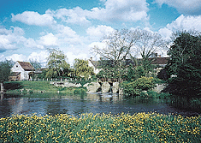
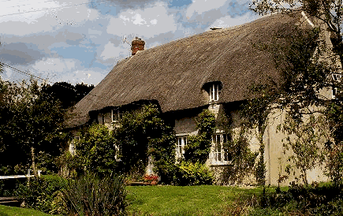
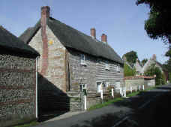
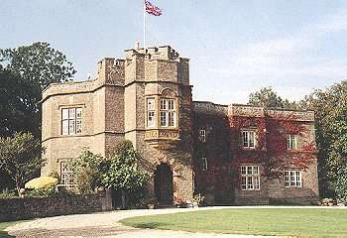

LAMPERTS COTTAGE HILFIELD MANOR FIDDLEFORD MILL WHITES DAIRY HOUSE SYDLING ST. NICHOLAS HILFIELD FIDDLEFORD PIDDLEHINTON

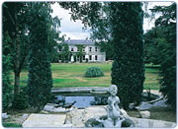
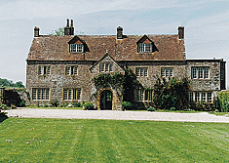
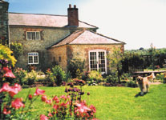
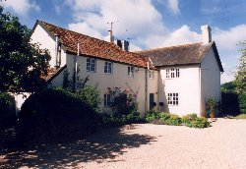

MUSTON MANOR BIRKIN HOUSE GRAYS FARMHOUSE HOLYLEAS HOUSE
PIDDLEHINTON STINSFORD TOLLER PORCORUM BUCKLAND NEWTON

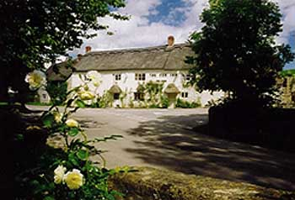
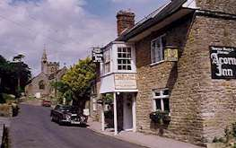
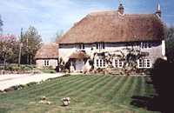
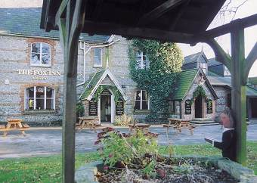

WHITFIELD FARM THE ACORN INN THE FOX INN THE FOX INN BRADFORD PEVERILL EVERSHOT CORSCOMBE LOWER ANSTY

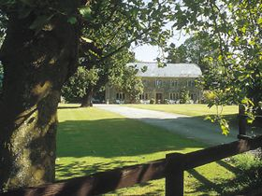
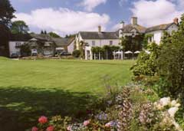
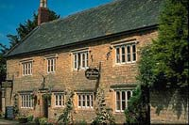
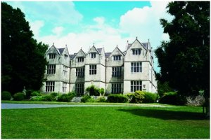

THE OLD MANOR BRIDGE HOUSE HOTEL PLUMBER MANOR SUMMER LODGE
KINGSTON MAURWARD BEAMINSTER STURMINSTER NEWTON EVERSHOT

LAMPERTS COTTAGE, SYDLING ST NICHOLAS – 16th Century thatched cottage in peaceful village in the unspoilt Sydling valley.
3 rooms. Bed and breakfast from £ 22.50 per person. No smoking. No credit cards.
Tel: +44 1300 341659, Fax: +44 1300 341669, e-mail: nickywillis@tesco.net
Further info: www.tuckedup.com/lampertscottage.html

HILFIELD MANOR, HILFIELD- Early 18th Century stone built manor house set in the glorious unspoilt surroundings of Hardy’s Wessex.
2 rooms. Bed and breakfast from £ 40.00 per person. Restricted smoking facilities. No credit cards.
Tel: +44 1963 210216, Fax: +44 1963 210881, e-mail: p.lindley@hilfield.co.uk
Further info: www.hilfield.co.uk

FIDDLEFORD MILLHOUSE, FIDDLEFORD – Grade I listed 16th Century mill house with views over the water meadow.
3 rooms. Bed and breakfast from £ 22.50 per person. No smoking. No credit cards.
Tel: +44 1258 472786, no fax, no e-mail.
Further info: www.tuckedup.com/fiddlefordmill.html

WHITES DAIRY HOUSE, PIDDLEHINTON – Grade II listed early 17th century former farm in the peaceful Piddle Valley.
5 rooms. Bed and breakfast from £ 25.00 per person. No smoking. No credit cards.
Tel: +44 1300 348386, Fax: same, e-mail: robin.adeney@care4free.net
Further info: www.whitesdairyhouse.co.uk or www.a1tourism.com/uk/whitesdairyhouse.html

MUSTON MANOR, PIDDLEHINTON – Charming 17th Century Manor House.
3 rooms. Bed and breakfast from £ 20 per person. No smoking. No credit cards.
Tel: +44 1305 848242, fax: same, no e-mail.
Further info: www.tuckedup.com/mustonmanor.html

BIRKIN HOUSE, STINSFORD – Victorian country house of great charm, recently restored to its former glory.
6 rooms. Bed and breakfast from £ 40.00 per person. No smoking. Most major credit cards accepted.
Tel: +44 1305 260262, Fax: +44 1305 259510, no e-mail.
Further info: www.birkinhouse.com

GRAYS FARMHOUSE, TOLLER PORCORUM –18th Century former shooting lodge set amongst a maze of paths and meadows.
2 rooms. Bed and breakfast from £ 25 per person. No smoking. No credit cards.
Tel: +44 1308 485574, no fax, e-mail: rosie@farmhousebnb.co.uk
Further info: www.farmhousebnb.co.uk or www.a1tourism.com/uk/grays.html

HOLYLEAS HOUSE, BUCKLAND NEWTON – Old country house set deep amongst rolling hills.
3 rooms. Bed and breakfast from £ 25 per person. No smoking. No credit cards.
Tel: +44 1300 345214, fax: +441300 264488, e-mail: TiaBunkell@Holyleas.co.uk
Further info: www.karenbrown.com/england/holyleas.html or www.tuckedup.com/holyleashouse.html

WHITFIELD FARM COTTAGE, BRADFORD PEVERILL – 200-year-old cottage full of charm and character.
3 rooms. Bed and breakfast from £ 24 per person. No smoking. No credit cards.
Tel: +44 1305 260233, Fax: same, e-mail: dc.whitfield@clara.net
Further info: www.dc.whitfield.clara.net

THE ACORN INN, EVERSHOT – Award winning 16th Century inn set in a charming village and used a great deal in film and television.
9 rooms. Bed and breakfast from £ 40 per person. Restricted smoking facilities. Most major credit cards accepted.
Tel: +44 1935 83228, Fax: +44 1935 83707, e-mail: stay@acorn-inn.co.uk
Further info: www.acorn-inn.co.uk

THE FOX INN, CORSCOMBE – Sister hotel to the Acorn at Evershot. Unspoilt 16th Century thatched pub of great character.
4 rooms. Bed and breakfast from £ 40 per person. No smoking in rooms. Most major credit cards accepted.
Tel: +44 1935 891330, Fax: same, e-mail: dine@fox-inn.co.uk
Further info: www.fox-inn.co.uk

THE FOX INN, LOWER ANSTY – Famous 250 year old inn in extremely picturesque setting.
14 rooms. Bed and breakfast from £ 35 per person. No smoking in rooms. Most major credit cards accepted.
Tel: +44 1258 880238, Fax: +44 1258 881440, e-mail: thefox@ansty.demon.co.uk
Further info: www.fox-inn-ansty.co.uk

THE OLD MANOR, KINGSTON MAURWARD – Stunning grade II listed Elizabethan Manor House.
4 rooms. Bed and breakfast from £ 40 per person. No smoking. Visa and MasterCard accepted.
Tel: +44 1305 261110, Fax: +44 1305 263734, e-mail: Thomson@kingston-maurward.co.uk
Further info: www.kingston-maurward.co.uk

BRIDGE HOUSE HOTEL, BEAMINSTER – 13th Century mellow stone hotel set in a pretty walled garden.
14 rooms. Bed and breakfast from £ 51 per person. Restricted smoking facilities. Most major credit cards accepted.
Tel: +44 1308 862200, Fax: +44 1308 863700, e-mail: enquiries@bridge-house.co.uk
Further info: www.bridge-house.co.uk

PLUMBER MANOR, STURMINSTER NEWTON – peacefully located early 17th Century manor house.
16 rooms. Bed and breakfast from £ 50 per person. Restricted smoking facilities. Most major credit cards accepted.
Tel: +44 1258 472507, Fax: +44 1258 473370, e-mail: book@plumbermanor.com
Further info: www.plumbermanor.com

SUMMER LODGE, EVERSHOT – Stunning Relais and Chateaux country house built in 1788 with Thomas Hardy as Architect.
18 rooms. Bed and breakfast from £ 77.50 per person. Restricted smoking facilities. All major credit cards accepted.
Tel: +44 1935 83424, Fax: +44 1935 83005, e-mail: reservations@summerlodgehotel.com
Further info: www.summerlodgehotel.com

