Mid Devon (Dartmoor)…
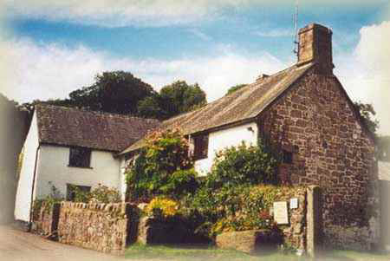
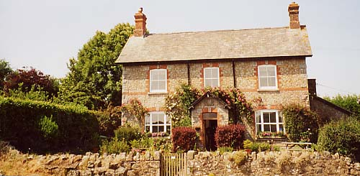
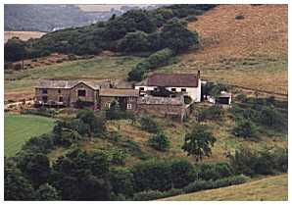
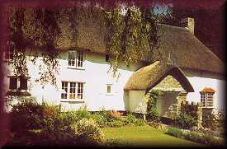

THE GATE HOUSE GREAT WOOSTON FARM GREAT LEIGH FARM GREAT SLONCOMBE NORTH BOVEY MORETONHAMPSTEAD DODDISCOMBSLEIGH MORETONHAMPSTEAD

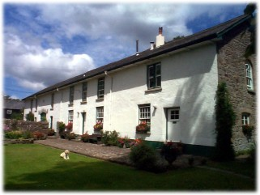
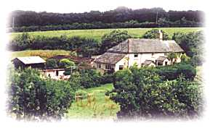
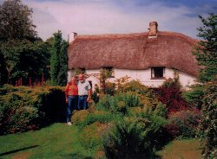
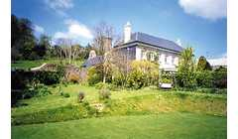

BLACKALLER WELLPRITTON FARM TOR DOWN HOUSE BAGTOR HOUSE
NORTH BOVEY HOLNE BELSTONE ILSINGTON

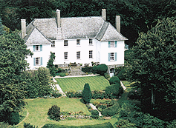
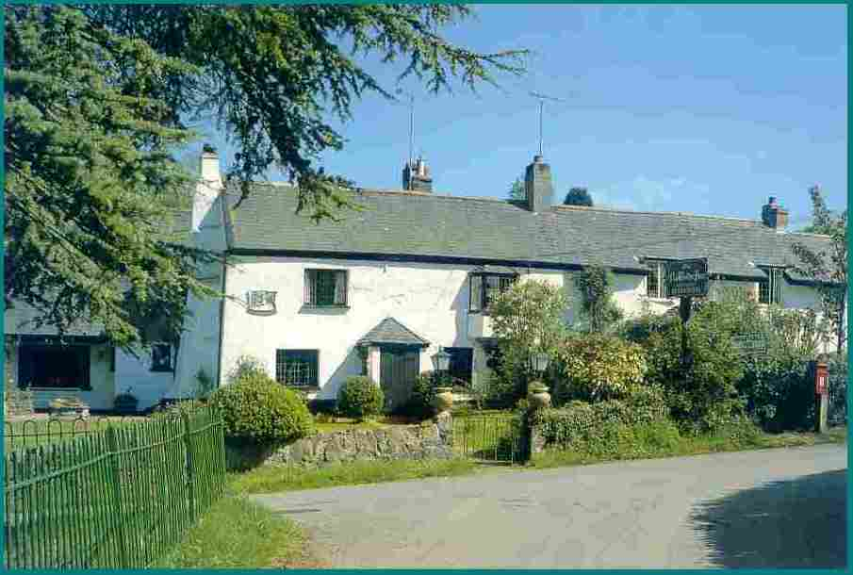
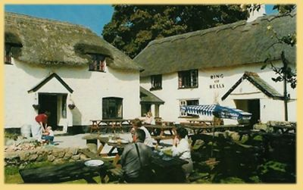
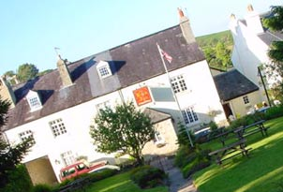

PENPARK RING OF BELLS THE ROCK INN NOBODY INN
BICKINGTON NORTH BOVEY HAYTOR VALE DODDISCOMBSLEIGH

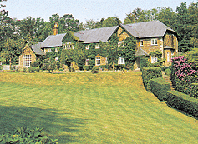
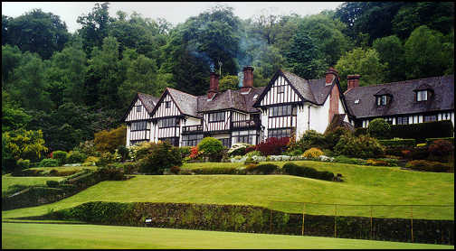
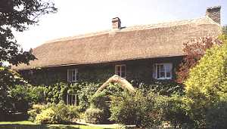
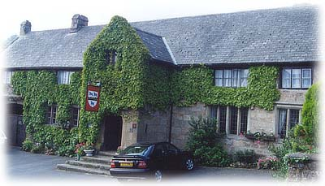

THE OXENHAM ARMS EDGEMOOR HOTEL EASTON COURT GIDLEIGH PARK SOUTH ZEAL BOVEY TRACEY CHAGFORD CHAGFORD

THE GATE HOUSE, NORTH BOVEY – Grade II listed medieval thatched Devon hall house.
3 rooms. Bed and breakfast from £ 30 per person. No smoking. No credit cards.
Tel; +44 1647 440479, Fax: same, e-mail: gatehousedartmoor@talk21.com
Further info: www.gatehouseondartmoor.freeserve.co.uk

GREAT WOOSTON FARM, MORETONHAMPSTEAD – Lovely farmhouse built in 1900 as part of the Lord Hambledon Estate.
3 rooms. Bed and breakfast from £ 21 per person. No smoking. No credit cards.
Tel: +44 1647 440367, Fax: same, e-mail: info@greatwoostonfarm.com
Further info: www.greatwoostonfarm.com

GREAT LEIGH FARM, DODDISCOMBSLEIGH – Working farm on 170 acres of gloriously isolated land and 240 yards of the River Teign.
4 rooms. Bed and breakfast from £ 27.50 per person. No smoking. No credit cards.
Tel: +44 1647 252048, Fax: +44 1647 253008, e-mail: janet@greatleigh.fsnet.co.uk
Further info: www.greatleigh.co.uk

GREAT SLONCOMBE FARM, MORETONHAMPSTEAD – 13th Century farmhouse on traditional Devon dairy farm.
3 rooms. Bed and breakfast from £ 23 per person. No smoking. No credit cards.
Tel: +44 1647 440595, Fax: same, e-mail: hmerchant@sloncombe.freeserve.co.uk
Further info: www.greatsloncombefarm.co.uk

BLACKALLER, NORTH BOVEY – Former 17th Century watermill set on the banks of the River Bovey.
6 rooms. Bed and breakfast from £ 34 per person. No smoking. No credit cards.
Tel: +44 1647 440332, Fax: +44 1647 441131, e-mail: peter@blackaller.freeserve.co.uk
Further info: www.blackaller.freeserve.co.uk

WELLPRITTON FARM, HOLNE – Isolated 18th Century farmhouse set in 15 wooded acres of beautiful countryside.
5 rooms. Bed and breakfast from £ 20 per person. No smoking. Most major credit cards accepted.
Tel: +44 1364 631273, no fax, e-mail: info@wellprittonfarm.com
Further info: www.wellprittonfarm.com

TOR DOWN HOUSE, BELSTONE – Beautiful 14th Century grade II listed archetypal thatched cottage with lovely gardens.
3 rooms. Bed and breakfast from £ 35 per person. No smoking. Visa and MasterCard only.
Tel: +44 1837 840731, Fax: same, e-mail: info@tordownhouse.co.uk
Further info: www.tordownhouse.co.uk

BAGTOR MANOR HOUSE, ILSINGTON – 14th Century Manor house in wonderful location.
2 rooms. Bed and breakfast from £ 25 per person. No smoking. No credit cards.
Tel: +44 1364 661538, Fax: same, e-mail: sawreysue@hotmail.com
Further info: www.sawdays.co.uk

PENPARK, BICKINGTON – Elegant Clough Williams designed Georgian country house.
4 rooms. Bed and breakfast from £ 28 per person. No smoking. No credit cards.
Tel: +44 1626 821314, Fax: +44 1626 821101, e-mail: gregson.penpark@ukgateway.net
Further info: www.penpark.co.uk

RING OF BELLS, NORTH BOVEY – Famous 13th Century thatched hostelry in lovely quiet village.
5 rooms. Bed and breakfast from£ 25 per person. Restricted smoking facilities. Most major credit cards accepted.
Tel: +44 1647 440735, Fax: +44 1626 207156, e-mail: info@ringofbellsinn.com
Further info: www.ringofbellsinn.com

THE ROCK INN, HAYTOR VALE – Typical 18th Century Dartmoor Inn of great charm and character.
9 rooms. Bed and breakfast from £ 33 per person. Restricted smoking facilities. Most major credit cards accepted.
Tel: +44 1364 661305, Fax: +44 1364 661242, e-mail: enquiries@rock-inn.co.uk
Further info: www.rock-inn.co.uk

THE NOBODY INN, DODDISCOMBSLEIGH – 2001 Pub of the year, built in the 16th Century and set in rolling countryside. Great food.
7 rooms. Bed and breakfast from £ 27.50 per person. Restricted smoking facilities. All major credit cards accepted.
Tel: +44 1647 252394, Fax: +44 1647 252978, e-mail: info@nobodyinn.co.uk
Further info: www.nobodyinn.co.uk

THE OXENHAM ARMS, SOUTH ZEAL – Creeper clad ancient Inn, built in the late 12th Century.
8 rooms. Bed and breakfast from £ 30 per person. Restricted smoking facilities. Most major credit cards available.
Tel: +44 1837 840244, Fax: +44 1837 840791, e-mail: jhenry1928@aol.com
Further info: www.hoteldevon.net

THE EDGEMOOR HOTEL, BOVEY TRACEY – Romantic country house hotel, built in 1870’s in a peaceful setting.
13 rooms. Bed and breakfast from £ 47.50 per person. Restricted smoking facilities. Most major credit cards accepted.
Tel: +44 1626 832466, Fax: +44 1626 83476, e-mail: info@edgemoor@btinternet.com
Further info@www.edgemoor.co.uk

EASTON COURT, CHAGFORD – Thatched country house from 1450, full of olde world charm.
8 rooms. Bed and breakfast from £ 40 per person. Restricted smoking facilities. Most major credit cards accepted.
Tel: +44 1647 433469, Fax: +44 1647 433654, e-mail: stay@easton.co.uk
Further info: www.easton.co.uk

GIDLEIGH PARK, CHAGFORD – Sublime country house hotel set in 45 magnificent acres on the banks of the River Teign.
16 rooms. Bed and breakfast from £ 150 per person. Restricted smoking facilities. All major credit cards accepted.
Tel: +44 1647 432367, Fax: +44 1647 432574, e-mail: gidleighpark@gidleigh.co.uk
Further info: www.gidleigh.com

