Bath & Avon…
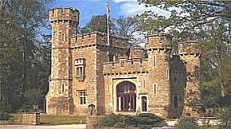
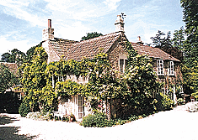
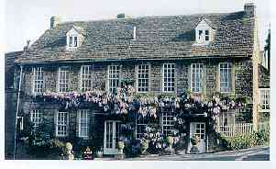
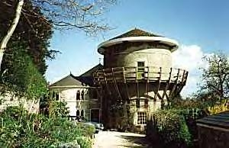

FERN COTTAGE BATH LODGE OLD WINDMILL THE PLAINE
MONKTON FARLEIGH NORTON ST. PHILIP BRADFORD-UPON-AVON NORTON ST. PHILIP

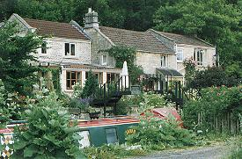
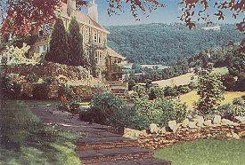
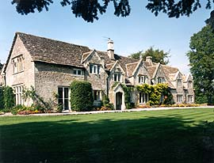
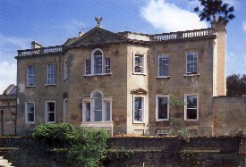

MONKSHILL DUNDAS LOCK COTTAGE BURGHOPE MANOR EAGLE HOUSE
MONKTON COMBE MONKTON COMBE WINSLEY BATHFORD

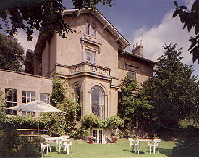
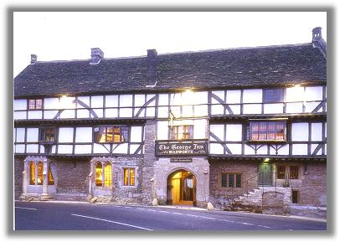
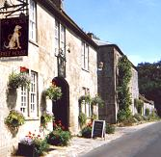
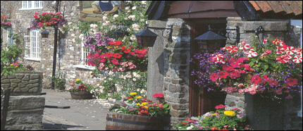

APSLEY HOUSE THE TALBOT INN THE GEORGE INN THE CARPENTERS ARMS
BATH MELLS NORTON ST. PHILIP STANTON WICK

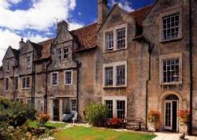
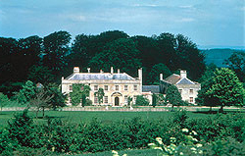
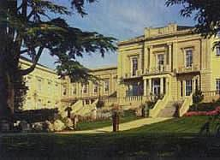
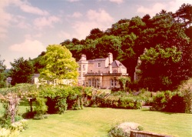

PARADISE HOUSE PRIORY STEPS HUNSTRETE HOUSE BATH SPA HOTEL
BATH BRADFORD-UPON-AVON HUNSTRETE BATH

FERN COTTAGE, MONKTON FARLEIGH – Lovingly restored grade II listed 16th Century stone cottage.
3 rooms. Bed and breakfast from £ 30 per person. No smoking. No credit cards.
Tel: +44 1225 859412, Fax: +44 1225 859018, e-mail: enquiries@Fern-Cottage.co.uk
Further info: www.fern-cottage.co.uk

BATH LODGE, NORTON ST PHILIP – One of six gothic hunting lodges built for nearby Farleigh house.
7 rooms. Bed and breakfast from £ 42.50 per person. No smoking. Most major credit cards accepted.
Tel: +44 1225 723040, Fax: +44 1225 723737, e-mail: walker@bathlodge.com
Further info: www.bathlodge.com

BRADFORD OLD WINDMILL, BRADFORD UPON AVON – Remarkable and eccentric 19th Century windmill.
3 rooms. Bed and breakfast from £ 35 per person. No smoking. Most major credit cards accepted.
Tel: +44 1225 866842, Fax: +44 1225 866648, e-mail: info@bradfordoldwindmill.co.uk
Further info: www.bradfordoldwindmill.co.uk

THE PLAINE, NORTON ST PHILIP – Delightful 16th Century family home retaining many original features.
4 rooms. Bed and breakfast from£ 27.50 per person. No smoking. No credit cards.
Tel: +44 1373 834723, Fax: +44 1373 834101, e-mail: theplaine@easynet.co.uk
Further info: www.bath.org/hotel/plaine.htm

MONKSHILL, MONKTON FARLEIGH – Beautiful country house with stunning views of the Limpley stoke valley.
3 rooms. Bed and breakfast from £ 32.50 per person. No smoking. Most major credit cards accepted.
Tel: +44 1225 833028, Fax: same, e-mail: monks.hill@virgin.net Further info: www.monkshill.com

DUNDAS LOCK COTTAGE, MONKTON COMBE – Built in 1801 this former lockkeepers cottage sits by a lovely stretch of canal in a quiet village.
2 rooms. Bed and breakfast from £ 25 per person. No smoking. No credit cards.
Tel: +44 1225 723890, Fax: same, e-mail: dundaslockcottage@freenet.co.uk
Further info: www.bath.org/hotel/dundas.htm

BURGHOPE MANOR, WINSLEY – 13th Century stone manor house with amazing views over the Avon valley.
3 rooms. Bed and breakfast from £ 42.50 per person. Restricted smoking facilities. Most major credit cards accepted.
Tel: +44 1225 723557, Fax: +44 1225 723113, e-mail: enquiry@burghope.co.uk
Further info: www.burghope.co.uk

EAGLE HOUSE, BATHFORD – Elegant Georgian house set in 2 acres with far reaching views.
8 rooms. Bed and breakfast from £ 26 per person. Restricted smoking facilities. Visa and MasterCard accepted.
Tel: +44 1225 859946, Fax: +44 1225859430, e-mail: stay@eaglehouse.co.uk
Further info: www.eaglehouse.co.uk

APSLEY HOUSE, BATH – Stunning Georgian house built in 1830 and standing in lovely gardens.
9 rooms. Bed and breakfast from £ 32.50 per person. Restricted smoking facilities. Most major credit cards accepted.
Tel: +44 1225 336966, Fax: +44 1225 425462, e-mail: info@apsley-house.co.uk
Further info: www.apsley-house.co.uk

THE TALBOT INN, MELLS – Ancient 15th Century inn with tithe barn and many outstanding medieval features.
8 rooms. Bed and breakfast from £ 40 per person. Restricted smoking facilities. Most major credit cards accepted.
Tel: +44 1373 812254, Fax: +44 1373 813599, e-mail: roger@talbotinn.com
Further info: www.talbotinn.com

THE GEORGE INN, NORTON ST PHILIP – Grade I listed building originally built as a monastic guesthouse over 600 years ago. Much used in film and television.
8 rooms. Bed and breakfast from £ 40 per person. Restricted smoking facilities. Most major credit cards accepted.
Tel: +44 1373 834224, Fax: +44 1373 834861, e-mail: info@thegeorgeinn-nsp.co.uk
Further info: www.thegeorgeinn-nsp.co.uk

THE CARPENTERS ARMS, STANTON WICK – A converted row of honey stoned miners’ cottages overlooking the scenic Chew valley.
12 rooms. Bed and breakfast from £ 40 per person. Restricted smoking facilities. Most major credit cards accepted.
Tel: +44 1761 490202, Fax: +44 1761 490763, e-mail: carpenters@dial.pipex.com
Further info: www.buccaneer.co.uk/carpentersarms/home.htm

PARADISE HOUSE, BATH – Classical 17th Century manor house in a tranquil garden setting with magnificent views.
10 rooms. Bed and breakfast from £ 32.50 per person. Restricted smoking facilities. Most major credit cards accepted.
Tel: +44 1225 317723, Fax: +44 1225 482005, e-mail: info@paradisehouse.co.uk
Further info: www.paradisehouse.co.uk

PRIORY STEPS, BRADFORD UPON AVON – Lovely hotel converted from a row of 17th Century weavers’ cottages.
5 rooms. Bed and breakfast from £ 37 per person. No smoking. Visa and MasterCard accepted.
Tel: +44 1225 862230, Fax: +44 1225 866248, e-mail: priorysteps@clara.co.uk
Further info: www.priorysteps.co.uk

HUNSTRETE HOUSE, HUNSTRETE – Grand 18TH century country estate in a perfect rural setting.
22 rooms. Bed and breakfast from £ 85 per person. Restricted smoking facilities. Most major credit cards accepted.
Tel: +44 1761 490490, Fax: +44 1761 490732, e-mail: enquiries@hunstretehouse.co.uk
Further info: www.hunstretehouse.co.uk

BATH SPA HOTEL, BATH – Extensive 19th Century mansion, now an extremely luxurious hotel of high standing.
102 rooms. Bed and breakfast from £ 127 per person. Restricted smoking facilities. All major credit cards accepted.
Tel: +44 1225 444424, Fax: +44 1225 444006, e-mail: info@bathspahotel.com
Further info: www.bathspahotel.com

